**CIS 375 – Fall 2019 Term Project - BRAINS**



Use Case Specification Document

**1**

**Answer Submission and Completion**

**Version No. 1.2.2**

**Project Document Revision History**

|  |  |  |  |
| --- | --- | --- | --- |
| **Version Number** | **Date** | **Revision Author** | **Description of Revision** |
| 1.0.2 | 10/27/2019 | Zakariya Ahmed | Creation of document |
| 1.03 | 10/30/2019 | Kevin Longworth | Updated flows |
| 1.1.0 | 10/30/2019 | Muaz Alhaidar | Updated written paths to match new flows of diagram |
| 1.2.0 | 12/13/2019 | Muaz Alhaidar | Updated Diagram and flows (to adjust to diagram) |
| 1.2.1 | 12/16/2019 | Muaz Alhaidar | Adapted document for the removal of the department’s ability to submit files to STENERS and Oversights ability to Remove STENERs |
| 1.2.2 | 12/17/2019 | Muaz Alhaidar | Further adjustments, changed introduction for compromise |

|  |
| --- |
| **Table of Contents** |

1. Introduction 4

2. Use Case Information 4

2.1 Actors 4

2.2 Use Case Interaction 4

3. Trigger 4

4. Pre-condition(s) 5

4.1 User has logged in as Department user 5

4.2 If user is receiving STENER, then no other prior condition is needed. 5

5. Post-condition(s) 5

5.1 STENER is being sent to oversight 5

5.2 System prints that STENER is Incomplete 5

6. Use Case Swimlane (Activity) Diagram 5

7. Main/Basic Flow(s) of Events (Happy Path) 6

7.1 STENER is successfully submitted 6

8. Alternate/Exception Flow of Events 6

8.1 Department sends an incomplete STENER 6

9. Assumptions/Business Rules including Non-Functional Requirements 6

10. Use Case Specification Review and Signoff 6

# Introduction

Write a single paragraph describing the purpose of the specific use case in the Introduction.

This use case deals with the Department’s ability to answer questions on the STENER and be able to enter a location where oversight can find evidence. The Department can also enter N/A as an answer to the questions.

# Use Case Information

## Actors

|  |  |  |
| --- | --- | --- |
| Actor Name | Role | Description |
| Database | Secondary | The middleman between Departments and the Oversight team |
| Departments | Main | They send/receive STENERS through the database |

## Use Case Interaction

How does this use case relate to other uses cases? List predecessor and successor use cases

.

This relates to other use cases because this is the process of sending/receiving STENERS: Use Case 2 (Login and Account Creation) is the authorization part of receiving/sending STENERS and Use Case 3 (Question Maintenance) is the creation of STENERS, come before Use Case 1. Use Case 4 (STENER Management) come after, which are the processing of the rejection/approval/updating of the STENERs.

# Trigger

What causes the use case to initiate?

When a Department/Oversight team receive/send STENERS. A department user clicks Answer/Submit STENER button.

# Pre-condition(s)

What use cases or other pre-conditions must be met before use can initiate?

## User has logged in as Department user

## If user is receiving STENER, then no other prior condition is needed.

# Post-condition(s)

What are ALL the possible output states upon completion of the use case flows?

## STENER is being sent to oversight

## System prints that STENER is Incomplete

# Use Case Swimlane (Activity) Diagram

Draw diagram(s) that cover ALL main and alternate flows.

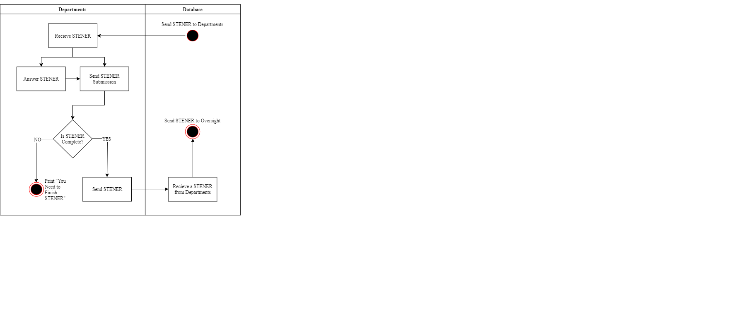

# Main/Basic Flow(s) of Events (Happy Path)

For each main flow (usually ONE flow) write the list of steps that occur – describe WHAT occurs not HOW to do it!

## STENER is successfully submitted

* Department receives a STENER
* Department fills out STENER
* Department sends STENER
* Database receives the STENER
* STENER is sent to Oversight

# Alternate/Exception Flow of Events

For each alternative flow (can be zero or more) write the list of steps that occur – describe WHAT occurs not HOW to do it!

## Department sends an incomplete STENER

* Department fills out STENER partially
* Sends STENER
* System states “ STENER is incomplete” and the user must finish filling out the STENER

# Assumptions/Business Rules including Non-Functional Requirements

Be sure to number the assumption/business rules to allow easy reference to them. Business rules will be where non-functional requirements are recorded – have a way to specifically identify non-functional requirements.

# Use Case Specification Review and Signoff

|  |  |  |  |
| --- | --- | --- | --- |
| Review and Signoff of the Use Case Specification | | | |
| Name | Project Team Role | Signature | Date |
| Ahmed, Zakariya | Senior Tech Lead/SPMP manager | Z.A. | 12/17/19 |
| Alhaidar, Muaz | Developer | M.A. | 12/17/19 |
| Longworth, Kevin | Developer | K.L. | 12/17/19 |
| Labut, Cameron | Developer | C.L. | 12/17/19 |
| Majzoub, Mostafa El | Developer | M.M | 12/17/19 |